

Information and Communication Technologies

The Gateway to the Future.



04 janvier 2024

Houari Boumediene University

Faculty of CS – Section A.

**Table of contents:**

* Introduction,
* History and revolution of TIC,
* The competence of TIC,
* Information and Communication Technology Basics,
* Technologies related to TIC:
  + GOOGLE SERVICES,
  + MICROSOFT,
  + GIT & GITHUB.
* Benefits of TIC.

***Introduction***

TIC competence refers to the knowledge, skills, and abilities required to effectively use information and communication technologies for various purposes, including gathering, processing, and presenting information. It is essential for individuals to possess a range of functional and critical thinking skills related to information, media, and technology to be effective in today's technology and media-suffused environment. Students with disabilities should also be provided with opportunities to develop TIC literacy and media literacy competencies. Various resources and standards describe what students should know and be able to do in terms of TIC competence. The European Commission added communication and relaxation as part of the application of TIC knowledge, skills, and ability. In summary, TIC competence is composed of three major dimensions: knowledge, skill.

*History and revolution of TIC*

The evolution of Information Technology and Communications (ITC) dates back to the mid-20th century, where innovations in computing saw the emergence of mainframe computers. In the 1960s, a significant breakthrough occurred with the advent of the Internet, leading to a profound transformation in communication and information transfer.

During the 1980s and 1990s, there was a proliferation of personal computers and notable advancements in software, paving the way for broader applications across various industries. In the 21st century, smartphones became indispensable, and we witnessed remarkable developments in cloud technologies and artificial intelligence.

These modern technologies play a crucial role in enhancing user experiences and enabling companies to improve efficiency and make better decisions through the analysis of big data. The history of ITC's evolution reflects significant progress in shaping the digital future and enhancing communication and interaction in all aspects of our lives.

*Competence of TIC*

The list of TIC components is exhaustive and continues to grow. Some components, such as computers and telephones, have existed for decades. Others, such as smartphones, digital TVs and robots, are more recent entries.

TIC components include the following:

* Devices (hardware).
* Software.
* Middleware.
* Data.
* Wired networks.
* Wireless networks.
* Communication technologies.
* The cloud.
* Communications protocols and interfaces.
* Information security and governance policies.

TIC means more than its list of components. It encompasses the application of all those various components. It's here that the real potential, power and danger of TIC emerges -- for economic, societal, and interpersonal transactions and interactions

*Information and Communication Technology Basics*

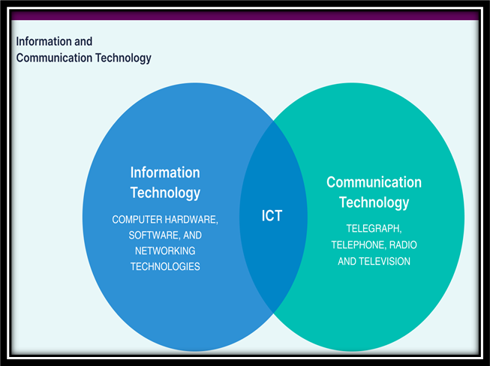

ICT is often used as a synonym for information technology (IT), but the two terms can have slightly different meanings when used in different contexts. In the United States, for example, the acronym ICT is used in more often in education because in that context, IT can also mean instructional technology. In some industries, IT only applies to enterprise computing, while the broader label ITC encompasses both IT and communication technologies.

Using IT and ICT interchangeably can lead to confusion, particularly in situations where the distinction between the two is important. For example, a job posting that requires expertise in IT may be different from one that requires expertise in ICT, as the latter may require additional skills that specifically support communication and collaboration tools.

*Technologies related to TIC*

1. ***GOOGLE SERVICES:***

Google offers a wide range of services that have become integral to many people's daily lives. It is the largest search engine, mapping and navigation application, email provider, office suite, video sharing platform, photo and cloud storage provider, mobile operating system, web browser, ML framework, and AI virtual assistant provider in the world as measured by market share. Some of the well-known services include Gmail, Chrome, YouTube, Google Trends, and Google Dashboard. These services cater to various needs, such as communication, information search, and entertainment, and are designed to make people's lives more convenient

Additionally, Google Play services is core system software that enables key functionality on every certified Android device, providing various APIs and core device services that support and improve the Android ecosystem.

1. ***MICROSOFT:***

Microsoft offers a diverse range of professional services and consulting solutions to help clients and partners adopt the latest Microsoft technologies and complete their projects. These services include enterprise services, consulting, support solutions, and proactive advisory services, all aimed at enabling businesses to become more digital and efficient. Microsoft's Professional Services organization is committed to protecting the data of its customers and adheres to privacy guidelines and compliance standards. The company also provides continuous hands-on assistance, staff training, risk assessments, and strategic advice to support a healthy IT environment. Additionally, Microsoft offers a variety of apps and services, such as Microsoft 365, SharePoint, Skype, Teams, and Visio, to facilitate collaboration and productivity.

The most famous applications of Microsoft:

* Word,
* Excel,
* Outlook,
* Power Point.
* *Word:*

Word is that it is a popular word processing application used for creating and editing text documents, presentations, and other content. It offers a user-friendly interface, advanced formatting options, and a wide range of templates to help users enhance their written communication and improve productivity.

* *Excel:*

Microsoft Excel is a powerful spreadsheet software program used for data visualization, analysis, and management. It offers features such as creating, viewing, editing, and sharing files, as well as tools for budgeting, chart creation, and data analysis. Excel provides modern templates, familiar formulas, and rich formatting options to enhance productivity and is available for various devices, allowing users to work on the go and collaborate in real time.

* *Outlook:*

Outlook is a personal email and calendar service offered by Microsoft. It allows users to send, receive, and manage their email, as well as keep track of appointments and events using its built-in calendar. Outlook is available for various devices, including Windows, Mac OS, iOS, and Android, and offers features such as real-time collaboration, smart inbox, and enterprise-grade security.

* *Power Point:*

Microsoft PowerPoint is a presentation software that allows users to create, edit, and present slideshows. It is part of the Microsoft Office suite and is available for Windows, Mac OS, iOS, and Android devices. PowerPoint offers a variety of features, including templates, design tools, and real-time collaboration, to help users create professional and engaging presentations. It also includes AI-powered tools such as Presenter Coach to help users improve their public speaking skills.

1. ***GIT & GITHUB:***

Git is a popular version control system used for tracking code changes, coding collaboration, and project management. GitHub is a web-based hosting service for Git repositories that provides developers with tools to ship better code through command line features, issues, pull requests, and more. GitHub allows developers to safely propose changes to production code, break down communication barriers between teams, and keep them focused on project transparency and collaboration. A repository, or Git project, encompasses the entire collection of files and folders associated with a project, along with each file's revision history. Git and GitHub are essential tools for developers to manage different versions of their code, collaborate with other developers, and build projects with others.

* *Comparing GitLab terminology:*

|  |  |  |  |
| --- | --- | --- | --- |
| Bitbucket | GitHub | GitLab | The meaning |
| Pull Request | Pull Request | Merge Request | In GitLab, a request to merge a feature branch into the official master is called a Merge Request |
| Snippet | Gist | Snippet | Share snippets of code can be public, internal or private. |
| Repository | Repository | Project | In GitLab, a project is a container including the Git repository, discussions, attachments, project-specific settings… |
| Teams | Organisations | Groups | In GitLab, Users can be added to groups and can manage group-wide notifications. |

*Benefits Of ICT*

* Efficiency: Improving processes and reducing errors.
* Communication: Facilitating communication and enhancing teamwork.
* Easy access: Convenient access to information for better decision-making.
* Global Connectivity: Connecting individuals and businesses worldwide.
* Cost Savings: Reducing costs through automation and digital processes.
* Data Management: Enhancing data management and analysis.
* Security: Safeguarding information from cyber threats.

|  |
| --- |
| *MADE BY* |
| *Nadir Maroua,* |
| *KOUCHKAR MARIA KAOUTER,* |
| *MENASRA NOUR EL IMENE,* |
| *SAIKI MERIEM,* |
| *touat nesrine.* |

*End.*